LMSAL Installation Instructions for SSW Jupyter Notebooks
Shelbe Timothy, 28 Aug 2020

- Install the Harris IDL-Python Bridge:
Instructions can be found here: https://www.harrisgeospatial.com/docs/python.html
As the instructions state, the bridge works best with Anaconda and bash environment. Installation instructions here: https://docs.anaconda.com/anaconda/install/. In the following steps, I will assume you have Anaconda installed (see conda commands).

The LMSAL instructions are as follows:
  - Add Python to your PATH and set your PYTHONHOME *(See .bashrc and .cshrc examples below)

  - Source the idl_setup file:
>> source $IDL_DIR/bin/idl_setup

  - cd to the $IDL_DIR/lib/bridges directory and run the following command:
>> python setup.py install

*Ultimately, I had to use this sudo command:
>> sudo PYTHONHOME='/Users/shelbe/anaconda3' python setup.py install)

  - Some examples to test the IDL-Python Bridge in either/both compilers:
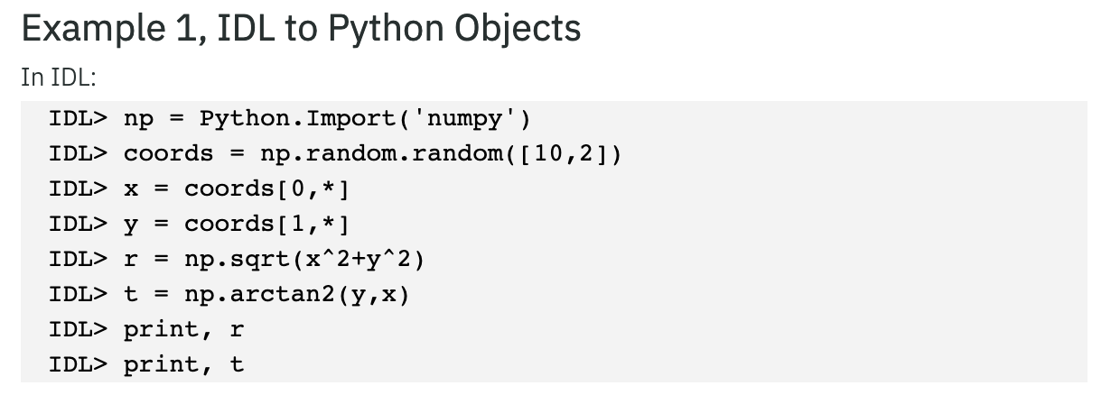
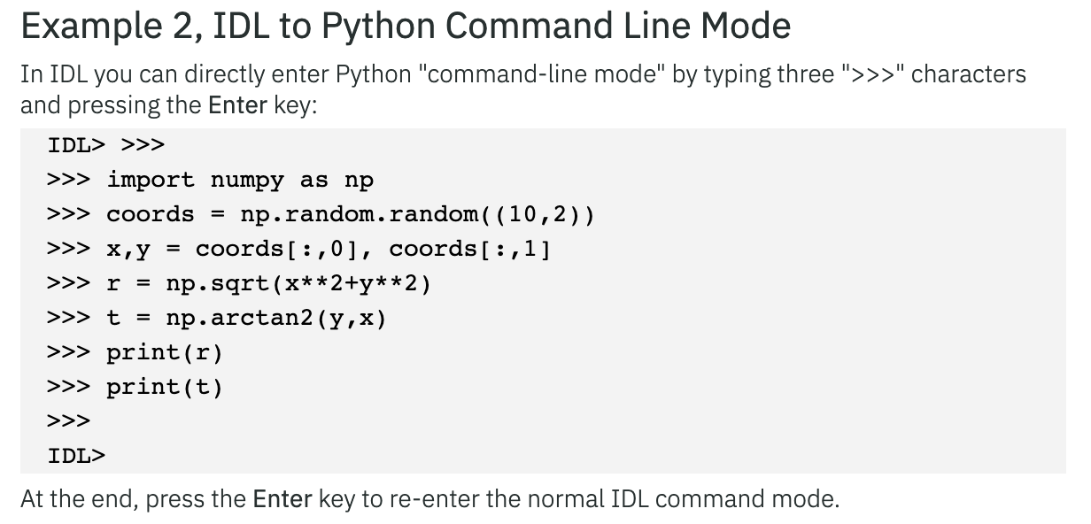
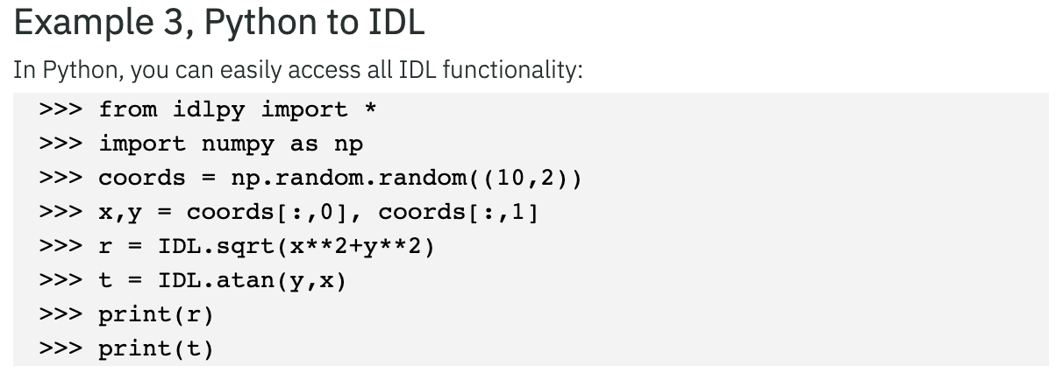

- Install IDL kernel to Jupyter notebooks:
Harris instructions can be found here: https://www.harrisgeospatial.com/docs/idl_kernel.html

The LMSAL instructions are as follows:
  - If you haven’t already, install Jupyter to your Python environment:
>> conda install jupyter

  - Set the variable JUPYTER_PATH to the IDL bridge directory, $IDL_DIR/lib/bridges.*

(Alternatively, you can copy the bridges/kernels/IDL/kernel.json into the Jupyter kernels directory, but I haven’t been able to get this method to work.)

  - Open Jupyter in the terminal:
>> jupyter notebook

  - Open a new or existing notebook, you should now be able to see two kernel options and be able to change between them freely! Use the examples above to test the compilers.

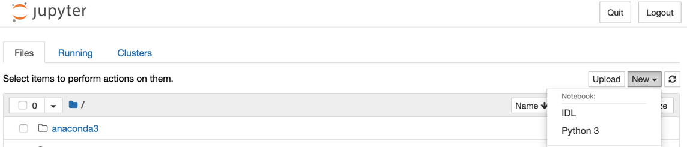

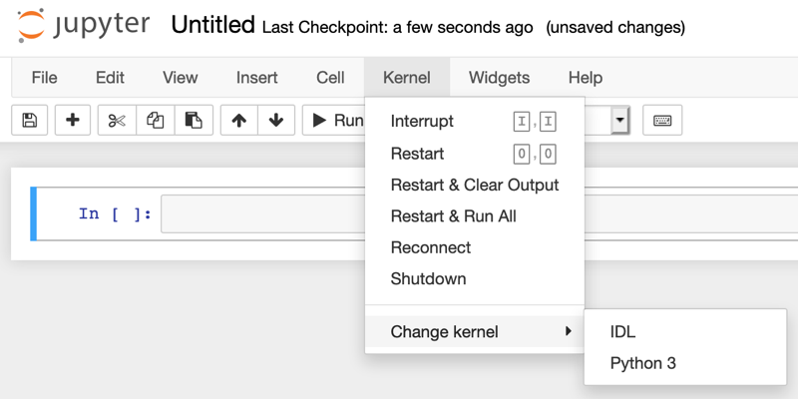

- Initialize the SolarSoft (SSW) Library:
At this point, if you’ve tried any SSW routines in the bridge or notebooks, you would have noticed that they do not work. In the future, this step may not be required if SolarSoft can be installed into your IDL environment as a package. For now, the SSW library must be initialized.

The LMSAL instructions are as follows:
- Two files must be sourced, one from the $SSW/gen/setup/ directory and one I have modified from the ssw_idl.csh script. This file initializes the SSW library without starting a new SSWIDL session and is located in the SSW notebook setup directory:
  - >> source $SSW/gen/setup/setup.ssw
  - >> source $SSW/packages/notebooks/setup/ssw_init.csh

Note: These are .csh files, to source them in bash use the following wrapper (This is done in ssw_jupyter.sh):
>> csh -c 'source {filename}; source {filename};exec bash'

- Now, you should be able to open a Jupyter notebook with a SSWIDL kernel! cd to the SSW notebook directory and start a new Jupyter session:
>> cd $SSW/packages/notebooks/setup/

- If you store the source commands in .cshrc all you need to do is open a new csh terminal and run a new jupyter session (hypothetically, I haven’t fully test the csh method!) In bash, you can copy the ssw_jupyter alias below* and use the following command in the bash terminal:
>> ssw_jupyter

- Open “SSWIDL Make Plot.ipynb” and test the first command block, if the SSW library isn’t available, you will see a “Variable is undefined: MAKE_MAP” error.

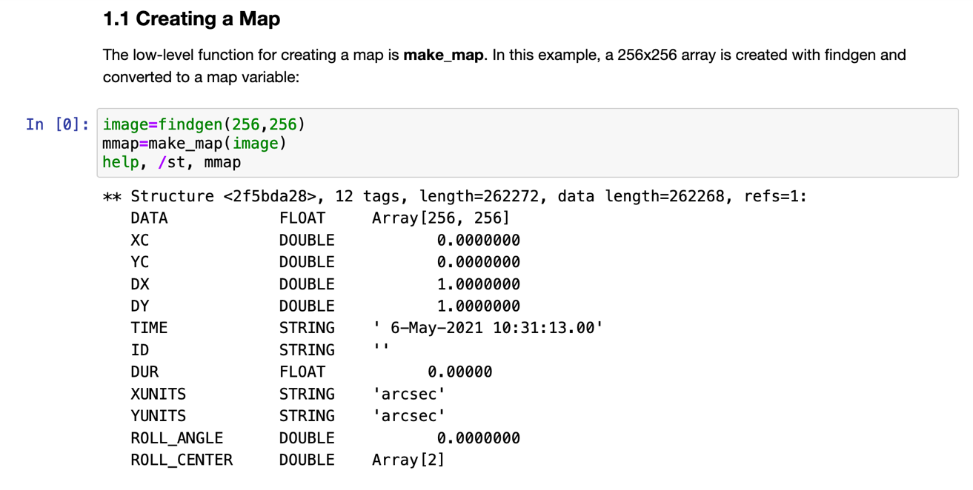

* Example .cshrc:
#!/bin/csh

# IDL->Python Bridge
setenv HARRIS_DIR /Applications/harris
setenv IDL_DIR $HARRIS_DIR/idl
source $IDL_DIR/bin/idl_setup
setenv PATH /Users/shelbe/anaconda3/bin:${PATH}
setenv JUPYTER_PATH $IDL_DIR/lib/bridges
setenv PYTHONHOME /Users/shelbe/anaconda3
setenv IDL_PATH /Applications/harris/idl/lib/bridges/:${IDL_PATH}

# SSW setup
setenv SSW /ssw
setenv SSWDB /archive/sswdb
source $SSW/gen/setup/setup.ssw
source $SSW/packages/notebooks/setup/ssw_init.csh

setenv DYLD_LIBRARY_PATH ''

* Example .bashrc (or .bash_profile)
#!/bin/bash

# IDL setup:
export HARRIS_DIR="/Applications/harris"
export IDL_DIR="$HARRIS_DIR/idl"
source $IDL_DIR/bin/idl_setup.bash
export PATH="/Users/shelbe/anaconda3/bin:$PATH"
export JUPYTER_PATH="$IDL_DIR/lib/bridges"
export IDL_PATH="$IDL_DIR/lib/bridges:$IDL_PATH"
export PYTHONHOME="/Users/shelbe/anaconda3"

# SSW setup
export SSW="/ssw"
export SSWDB="/sswb"
alias sswidl="$SSW/gen/setup/ssw_idl"
alias ssw_jupyter="$SSW/packages/notebooks/setup/ssw_jupyter.sh"

export DYLD_LIBRARY_PATH=""

*Troubleshoot options for step 1c:
- Check the bin.darwin.x86_64 for a compatible bridge version. IDL 8.7 supports Python 2.7, 3.5, and 3.6. IDL 8.8 supports Python 3.6, 3.7, and 3.8.

Ex. /Applications/harris/idl87/bin/bin.darwin.x86_64/pythonidl36.so

- Note that the python setup.py install step MUST be called from the BASE environment. PYTHONHOME is managed by the Anaconda and cannot be called from another environment.

- If you see the following error, run as sudo: sudo python setup.py install

(base) poipu:bridges shelbe$ python setup.py install

Installing the IDL Python bridge.
Python-to-IDL library location:
/Applications/harris/idl87/bin/bin.darwin.x86_64/pythonidl36.so
IDL-to-Python library location:
/Applications/harris/idl87/bin/bin.darwin.x86_64/idl_python36.so

Setting Python library location within IDL libraries

Python library location:
/Users/shelbe/anaconda3/lib/libpython3.6m.dylib

install_name_tool -change libpython3.6m.dylib /Users/shelbe/anaconda3/lib/libpython3.6m.dylib /Applications/harris/idl87/bin/bin.darwin.x86_64/pythonidl36.so
error: /Library/Developer/CommandLineTools/usr/bin/install_name_tool: can't open input file: /Applications/harris/idl87/bin/bin.darwin.x86_64/pythonidl36.so for writing (Permission denied)
error: /Library/Developer/CommandLineTools/usr/bin/install_name_tool: can't lseek to offset: 0 in file: /Applications/harris/idl87/bin/bin.darwin.x86_64/pythonidl36.so for writing (Bad file descriptor)
error: /Library/Developer/CommandLineTools/usr/bin/install_name_tool: can't write new headers in file: /Applications/harris/idl87/bin/bin.darwin.x86_64/pythonidl36.so (Bad file descriptor)
error: /Library/Developer/CommandLineTools/usr/bin/install_name_tool: can't close written on input file: /Applications/harris/idl87/bin/bin.darwin.x86_64/pythonidl36.so (Bad file descriptor)

*** install_name_tool failed.

*** Check the paths above, or run the script as 'sudo python setup.py'.

- If you see the following error, set the PYTHONHOME variable inside the sudo command:
sudo PYTHONHOME='/Users/shelbe/anaconda3' python setup.py install

(base) poipu:bridges shelbe$ sudo python setup.py install

Installing the IDL Python bridge.
Python-to-IDL library location:
/Applications/harris/idl87/bin/bin.darwin.x86_64/pythonidl36.so
IDL-to-Python library location:
/Applications/harris/idl87/bin/bin.darwin.x86_64/idl_python36.so

*** PYTHONHOME environment variable must be set to your Python installation.

